World Views
- What is a world view?

- What creates a person or societies world views?

- How can different worldviews lead to positive outcomes? Give specific examples?

- How can different worldviews lead to negative outcomes? Give specific examples?

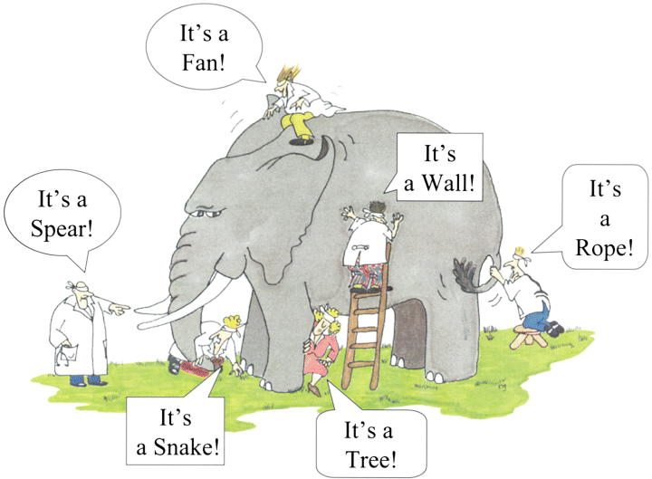
- Describe how this picture is a great example of different world views.

- How does worldview affect status and importance?

- Create a poster that shows how different worldviews can be positive or negative. Choose either one.

