http://reissocialstudies9.weebly.com/

Social Studies 9
Mr. Reis
Room 120
Welcome to Social Studies 9!!!
Social Studies 9 focuses on the growth of civilizations. We will look at the growth of societies and cities over thousands of years. Starting with the Prehistoric people and using examples like the people of Mesopotamia, the Ancient Greeks and Romans we will see how groups of people settled and started to build cities and empires. We will also start to look at the Dark Ages and the Renaissance to show how societies adapted and changed as they started to grow.
Google Classroom
The website will be one tool we use to access class information, we will also be using Google Classroom to keep track of assignments and help in handing students work in. If we ever need to switch to online learning, we can meet, chat and do many other things to ensure that the students have the opportunity to continue to learn.
Our Google Class code is – 2hc4nwv
Students will use their school log in information (ab123s) to access their Google account.
Remind(ers) and communication
To communicate with the students and parents, I have always used an App called Remind. It allows me to send messages to parents and students as text messages, but we don’t share numbers. You don’t need to download an app, all you need to do is follow the directions below. If you have any questions, please feel free to message me. Just so you know, that is not my number, so please don’t call it.

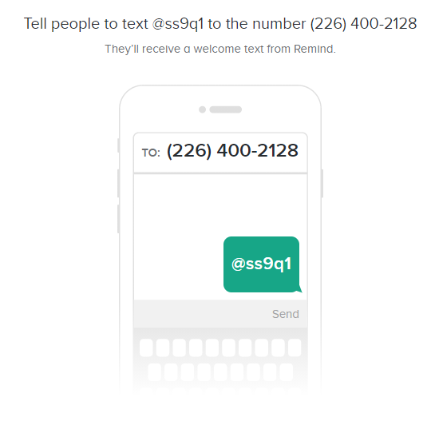
You can also email me at jesse.reis@spiritsd.ca

I also have a website where all of the class material will be uploaded and available. It is www.reissocialstudies9.weebly.com . Here you will find everything that you need for the course. It always update it the night before class, so it may change as we go through the year.

What does Social Studies 9 look like this year?
Well seeing that we have a 2-hour class, we are going to be very structured in class. A typical class will look like this.
Class begins – 12:55
15-20 minutes - Reading/researching – Mr. Reis has books from the library available for us the class, but students can also bring personal devices to class. Laptops, tablets or phones are allowed in class when they are used appropriately. To go along with this time. There will be a question to guide our learning.
40 Minutes - Lesson Part 1 – This will be the first lesson portion of the class. Seeing that we only have just over 2 months together we need to make sure we get to work!!!
10-15 Minutes – Body Break/ Connection Break – This will be an opportunity for us to go outside as a class, or if we can’t to stay inside but take a break from curriculum and allow us the opportunity to connect with each other. If we can, we will also use this time to meet curricular outcomes by identifying connections in our community.
40 Minutes – Lesson Part 2 – Seeing as we need to keep on keepin’ on… we will do the second lesson. It may build off of lesson 1, or be something completely different.
Class Ends – 3:07
Do we need to wear masks?
When we can’t be 2 meters apart, yes you need to wear a mask. I will do my best to make sure there are activities where masks are not required but please always have one available. If you are more comfortable wearing a mask all the time, I’m cool with that.
What do we learn in Social Studies 9?
This is one of my favorite classes to teach, we look at the organizing and growth of people through history. We look at over 10 000 years of history to see why we have gone from small groups of people to large cities with millions of humans!!!

