The Dawn of Agriculture

Overview
- Agriculture likely began during the Neolithic Era before roughly 9000 BCE when polished stone tools were developed and the last ice age ended.
- Historians have several theories about why many societies switched from hunting and foraging to settled agriculture.
- One of these theories is that a surplus in production led to greater population. Not everyone needed to be focused on food production, which led to specialization of labor and complex societies.

The world before agriculture
Based on current archeological evidence, anatomically modern humans have existed roughly 200,000-300,000 years. However, before roughly 15,000-20,000 years ago, we have no evidence that our ancestors had agriculture. Instead, we believe they strictly hunted or foraged for food. There were times when they had a big kill and had more food than they knew what to do with. There were other times when they over foraged or hunted and they didn’t know how many days it would be until their next meal. If they didn’t find food, they or their families would starve. Even when there was food, it might take miles of walking to find it. For many of these preagricultural societies, a good bit of their energy went into just getting more energy—in other words, food—to keep going and reproduce.
There also couldn’t be too many humans living in one area since there was only so much food to be found or killed. Because of this, a tribe of 100 hunter-foragers would have needed to be the only humans on 50 to 500 square kilometers to survive—places lush with life, like tropical rain forests, could support a higher density. With only hunting and foraging to support human populations, it is estimated that the Earth could only support about 10 million people. Historians estimate the world population was around six to ten million 10,000 years ago.

The birth of agriculture
About 10,000 to 15,000 years ago, humans began to mold nature to their needs and agriculture emerged in multiple places around the planet. We believe that it emerged independently and spread from places as varied as Mesopotamia, China, South America and sub-Saharan Africa. As we explore more, it is likely that scientists will find more places where agriculture may have emerged even earlier. The birth of agriculture is often referred to as the Neolithic Revolution since it seems to coincide with the Neolithic period—or new stone age. The Neolithic period’s name stems from the fact that stone artifacts were more smooth and refined than those of the Paleolithic period, or old stone age. Many of these tools facilitated early agriculture.^11start superscript, 1, end superscript
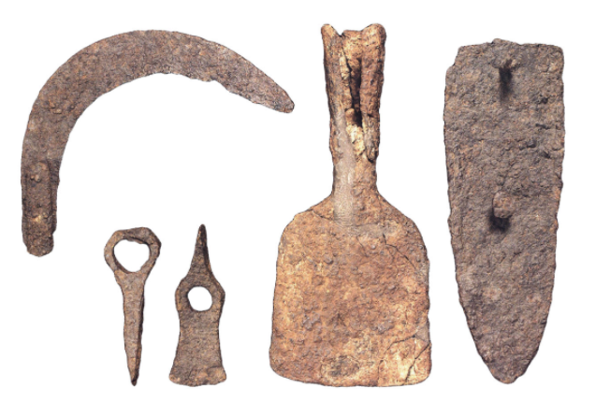
Agricultural tools found in the Iberian settlement Bastida of Alcusses, ca. late 5th century B.C.E. to the 4th century B.C.E. Image courtesy Wikimedia Commons.
The first agriculture was likely cultivation of wild species of plants and basic herding of livestock. As time went on, humans became more and more sophisticated at breeding the plants and livestock that best met our needs. The corn you see in the grocery store and the pigs, cows, and sheep you see at a farm did not evolve independently in the wild. They are the product of thousands of years of human selection and breeding from original, wild forms.

Why did agriculture emerge when and where it did?
The simple answer is that we’re not sure. We do, however, have several theories—can you think of more?
- End of a glacial period: The last glacial period ended 10,000 to 15,000 years ago. This seems to coincide with the emergence of agriculture. After the glacial period ended, there was more moisture in the air, less frozen soil, and better conditions overall for more plant and animal life. These conditions would have also been more suitable for agriculture. This theory still has several open questions:
1) Why have we not found evidence of agriculture during the last interglacial—warmer—period over 100,000 years ago? Have we just not found it yet?
2) Even during the glacial period, weren’t there some places on Earth in the tropics that would have still been suitable for agriculture?
- Continued human development: Even though anatomically modern humans have been around for roughly 200,000 years, our brains, language, and culture may have continued to develop and change—including through natural selection. It is possible that only 10,000 to 20,000 years ago did we first have the right mix of environmental, mental, and cultural development to implement agriculture. This theory is bolstered by the fact that the dawn of agriculture seems to coincide with humans being able to make the more sophisticated stone objects which define the Neolithic period.

Pastoralism: a branch of agriculture
A branch of agriculture—called pastoralism—began around the same time as cultivation of plants. Pastoralism is the domestication and herding of animals such as goats, sheep, and cattle. In regions where plant cultivation proved difficult due to rocky terrain or climates that were inhospitable to plants, pastoralists herded animals. While many pastoralists were nomadic, their lifestyle differed fundamentally from that of hunter-foragers in that they did not rely exclusively on naturally occurring resources. They milked animals for dairy products and used their wool to weave textiles, which they could trade with agricultural societies if they lived in close enough proximity to them.
A mix of cooperation and conflict resulted from the relationship between pastoralists and farmers. Pastoralists’ military-related artifacts suggest that they may have come into conflict with farming societies; however, in other cases, pastoralists traded goods with farmers in a cooperative relationship.

Impact of agriculture
The impact of agriculture has been profound on humanity, most clearly in terms of population. This is because breeding plants and animals has significantly increased the availability of human consumable calories per square kilometer. One way to think about it is that we replaced things that weren’t consumable by humans with things that were. Through techniques like irrigation, we were also able to make things grow where they might not have before.
To put this in perspective, before the agricultural revolution experts estimate that there were six to ten million people, which is about how many hunter-foragers the Earth could sustain. By the time of the Roman Empire, about 10,000 years later, the world population had grown over 25-fold to 250 million. Fast forward 2000 years to the present, and the population has grown another 28-fold to seven billion. In roughly 10,000 to 15,000 years, advances in agriculture have allowed the human population to become roughly 1000 times larger!
Agriculture also has had environmental impacts. Farmers used complex tools to cultivate and irrigate their fields and to build settlements. To expand their amount of usable land, agriculturalists cleared forests using the slash and burn technique; they would remove a ring of bark from the trees, drying out the trees and allowing them to burn more quickly. The ash from the trees acted as a fertilizer for the soil.
Pastoralism also brought challenges to the environment and people. Herds of animals concentrated in one area could overgraze the land, ultimately rendering it unusable or subject to erosion. In addition, with a closer proximity to animals, came a higher likelihood that diseases could be transmitted from animals to humans.
By actively managing their food supplies, agricultural societies were able to produce more food than hunter-foragers and support denser populations. Having a large population nearby made it worthwhile for farmers to grow more food than they needed for themselves, as they could trade this surplus for other goods. For non-farmers, this meant that they could focus on making other goods and trading these goods for food and other things. People could specialize—focus on doing one thing—which led to increased productivity. Increased productivity led to the creation of better buildings, tools, weapons, and also to the rise of governments to oversee this activity and military forces to protect people and resources.
Many population centers evolved into the first wave of city-states that emerged within a few thousand years of the agricultural revolution. Eventually those states began to have complex bureaucracies to tax and administer their people, a significant catalyst for the birth of writing, which was transformational for civilization.

