Ancient Civilization Assignment
Step 1 – Pick an Ancient Civilization, here are some options
Inca China(Zhang Line) China (Western Zhou) China (Eastern Zhou)
Ancient Japan Nazca Zapotec Haida Coast Salish
Nisga’a Tlinglit Wyandot People Hittites Mongols
(If you find an ancient society that I may have missed, you can ask me if you can do it)
Step 2 – Research your group of people and find out relevant information that you can use to prove to the class that the group you chose should be considered a civilization.
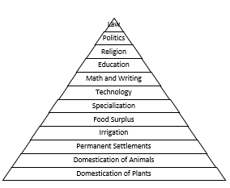
You can use the Civilization Pyramid as your guide but know that some groups may not hit all stages or may reach them differently. For example – If a group never Domesticated animals, how did they get food from animals or who helped with the work on the farm.
It will help if you explain why you think this worked to grow the society.
Another relevant pieces of information will be their time frame and their location.

Step 3 – How will you present your information.
- You can do this electronically or on a poster board or how ever you would like… it’s your choice. You just need evidence of learning that you can give to me and show case to your classmates.
- Pictures help show great examples and if you can explain those pictures, it helps you to prove your point
What Should I be looking for?
Domestication of Plants
Domestication of Animals
Permanent Settlements
Irrigation
Food Surplus
Specialization
Technology
Math and Writing
Education
Religion
Politics
Law

